A database index isn't a magic performance switch—it's a calculated trade-off.
As your tables grow from a few thousand rows to millions, queries that took milliseconds can suddenly take seconds. This happens when the database engine is forced to perform a full table scan, reading every single row to find a match.
Adding an index creates a separate, sorted data structure (usually a B-Tree) that acts as a lookup table. Instead of scanning millions of rows, the database traverses a tree, making binary decisions at each branch. Finding a row in a 10-million-row table might only require reading 3 or 4 pages.
But indexes come with a strict cost:
1. Write Overhead: Every time you INSERT, UPDATE, or DELETE a row, the database must also update every associated index. On high-throughput logging tables, excessive indexing will severely throttle write performance.
2. Storage Costs: Indexes duplicate data. Indexing half the columns in a wide table can easily double your storage footprint.
3. Diminishing Returns: Indexing low-cardinality columns (like a boolean status field) provides almost no filtering benefit.
The best approach is strategic indexing. Focus on high-cardinality columns (like emails or UUIDs) and columns consistently used in WHERE, JOIN, or ORDER BY clauses. Always use EXPLAIN ANALYZE to verify your queries are actually utilizing the indexes you create.
You can visually inspect your execution plans and manage indexes across PostgreSQL, MySQL, and SQL Server without writing raw SQL using DBO Studio. Read the full breakdown of index types and trade-offs here: https://lnkd.in/eP-NZU3M
Activate to view larger image,
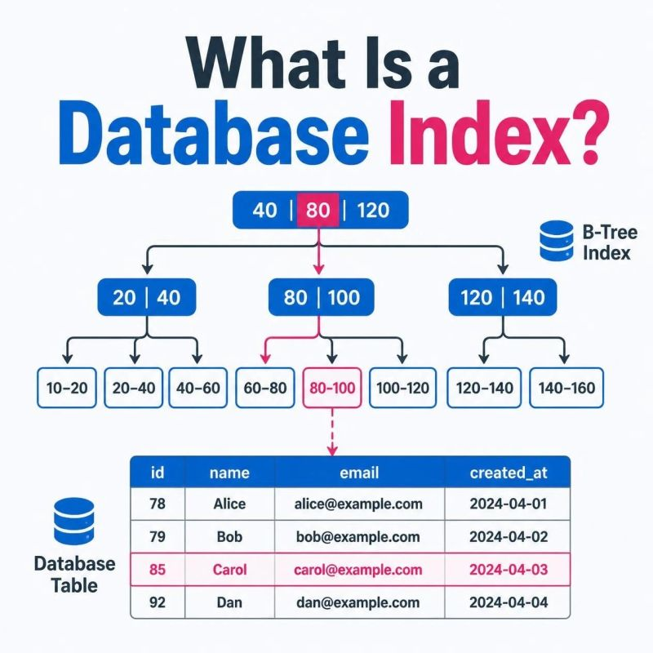

Your database is not slow.
Your indexes are wrong.
Every engineer reaches a point where adding RAM stops fixing things.
That's when they finally learn indexing properly.
Here are the 8 indexes that actually move the needle - and when to use each 👇
🔹 𝗕-𝗧𝗿𝗲𝗲 (𝘁𝗵𝗲 𝗱𝗲𝗳𝗮𝘂𝗹𝘁)
For equality + range queries. ORDER BY, BETWEEN.
The one you already use, whether you know it or not.
🔹 𝗛𝗮𝘀𝗵
For pure equality lookups. O(1) speed. No ranges, no sorts.
🔹 𝗖𝗼𝗺𝗽𝗼𝘀𝗶𝘁𝗲
For multi-column WHERE filters. Get the column order wrong, and it's useless.
🔹 𝗕𝗶𝘁𝗺𝗮𝗽
For low-cardinality columns. Brilliant on reads, painful on writes.
🔹 𝗖𝗼𝘃𝗲𝗿𝗶𝗻𝗴
Includes every column the query needs. The DB never touches the table.
🔹 𝗣𝗮𝗿𝘁𝗶𝗮𝗹
Indexes a subset of rows. Smaller. Faster. Cheaper.
🔹 𝗙𝘂𝗹𝗹-𝗧𝗲𝘅𝘁
For keyword search and search-as-you-type. Goodbye, brute-force LIKE.
🔹 𝗚𝗜𝗡 / 𝗚𝗶𝗦𝗧
For JSON columns, arrays, and geospatial data. Postgres magic.
Good engineers know SQL.
Great engineers know which index to reach for.
The difference is a query that takes 3 seconds vs 3 milliseconds.
Save this. Show it to anyone who says "we need a bigger database."
Follow for more such insights!!
Activate to view larger image,


